Research Report Front-End Framework

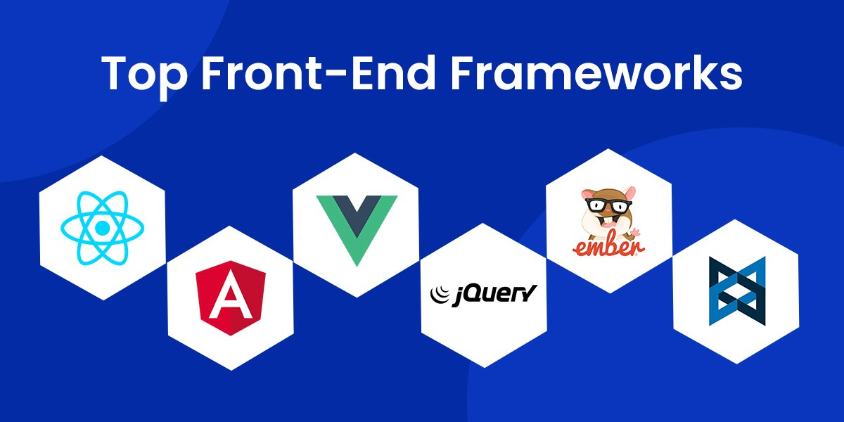

By Jonathan Kat

# Table of Contents

Contents

Table of Contents 2

Introduction 3

Main Question 4

Methodology 4

Criteria 4

Research Questions 5

What three frameworks did I choose to research? 5

What are the restraints of my project? 6

What is the learning curve of each framework? 6

How big and Active is the Community? 6

At what scale are the frameworks used best? 7

How do the Components work? 7

Summarizing the Frameworks 8

React 8

Angular 8

Vue.js 8

Conclusion 9

Sources 10

# Introduction

Front-end frameworks are a great tool in the development of web applications. These frameworks provide a structured foundation for making a responsive and interactive web application. Choosing the right front-end framework for any project is an important decision that can have impact in both the development and success of the application. In this report I will be comparing three different frameworks to see which one I could use for my project.

# Main Question

For this report I will be answering my primary research question:

**Main Question:** “Which front-end framework should I use for my project?”

I will answer this question by answering several sub-questions to provide myself with an extensive analysis and recommendation.

# Methodology

## Criteria

To determine which framework I should use in my project I will need to evaluate the following criteria:

* The framework has to be beginner friendly because I have never worked with a front-end framework before.
* The community around the framework should be active and helpful to help me in my quest to build a web application with a front-end framework.
* There has to be enough documentation and the documentation has to be well maintained
* The framework has to be suited for the size of my project.

# Research Questions

## What three frameworks did I choose to research?

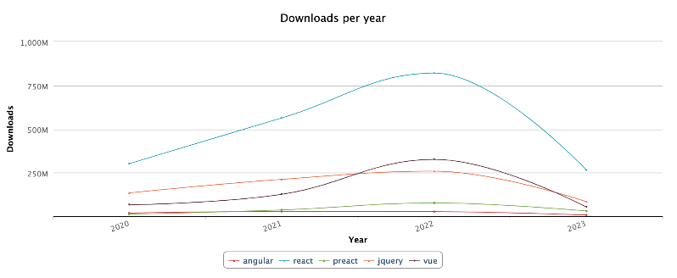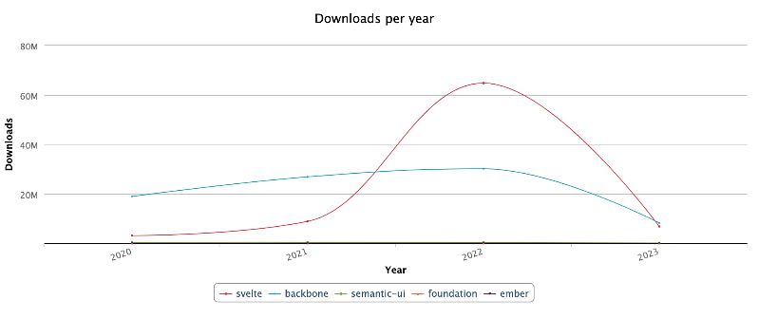There are many different Javascript frameworks I would be able to research, but if I were to research every single one of them I wouldn’t be done untill 2030, so I limited myself to only choose 3 frameworks to research. The only question remaining is which one.

*Figure 1 | Frontend framework downloads per year. Source:* [*npm-stat*](https://npm-stat.com)

So I went looking for frameworks that would be very popular. I wanted to use a popular framework because I think when a framework is popular, and a lot of people use it, that there would be more than enough help that I would need to use the framework myself in my own project.

I first looked at which framework had the most downloads, because in my eyes if a framework has loads of downloads that it is probably a very popular framework. In figure 1 you see that the top 5 frameworks with the most downloads in the past few years are React, Angular, Vue, Preact and Jquery. With in 2022 Vue taking over 2nd place from Angular only for Angular to take it back in 2023.

After I found this I started thinking, the amount of downloads doesn’t necessarily mean it is the most popular. People start new projects all the time and since people are familiar with a certain framework there is a high chance that they will use that same framework again, and again, and again. So this way of finding the most popular framework might not be the best.

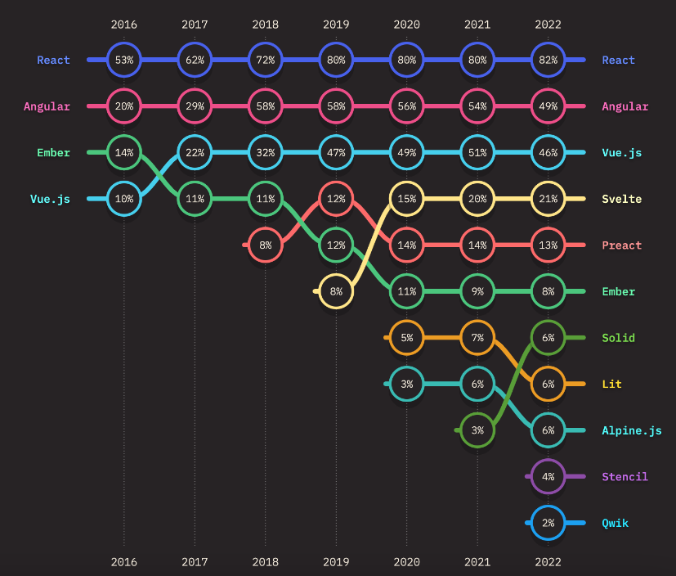Then I started researching which framework developers used most often. This is because this singles out developers’ usage instead of the amount of times the framework was downloaded.

Figure 2 | Frontend frameworks usage ratio over time. Source: [State of JS 2022](https://2022.stateofjs.com/en-US)

In Figure 2 you can see that the top 3 are React, Angular and Vue. You may have noticed that the top 3 just happen to be same as in Figure 1. Which, in retrospect, does make sense. Because when a framework is used a lot then it is going to be downloaded a lot, even if the same developers use the framework for multiple of their own projects.

In conclusion I will be choosing to research the three frameworks that are the top 3 in both graphs. React, Angular and Vue.js.

## What are the restraints of my project?

To be able to choose the right Framework for my project, knowing the restraints of my project is essential. Based on the restraints I am able to pick the right framework for my project. Firstly my project will be pretty small, so I have to choose the right framework which is built for smaller projects. Secondly, this is my first time working with a front-end framework, so I’ll have to pick a framework which is easy and fast enough to learn and has enough documentation so I can get started quickly.

## What is the learning curve of each framework?

I have never used a Front-End framework before, so I have to choose one which has a low enough learning curve so I don’t have to spend lots of time into learning this framework.

* React

React is known for its relatively low learning curve. It offers a Getting Started guide that will help setting up. The learning curve for learning the core of React may be low, but the learning curve could become steeper depending on the path you take with using additional functionality by third-party libraries.

* Angular

Angular has a steep learning curve, considering it is a complete solution, makes lots of sense.

Learning Angular requires you to learn concepts like TypeScript and MVC.

* Vue.js

Vue provides high customizability and makes it easier to learn than Angular or React. Vue has a gentler learning curve compared to the other two Frameworks, which is great for both beginners and experienced developers alike.

## How big and Active is the Community?

Having a strong community can come in useful when you need support during your development.

* React

React has an active community, the most common issues have solutions In other places like Stack Overflow. Because React is not a complete framework some more advanced features require the use of third-party libraries (made by the community).

* Angular

Angular has a strong community, mainly in enterprise development. Angular also has extensive official documentation.

* Vue.js

Being the youngest of the three, Vue has an ever growing community and gaining popularity every single day. Vue also has great documentation to help you getting started.

# At what scale are the frameworks used best?

It’s important to make sure I will use a framework which is best for the size of my project.

* React

React is very flexible in terms of scalability, it can be used for both smaller projects and more complex projects

* Angular

Angular is best suited for big and complex projects, mainly used in enterprise development.

* Vue.js

Vue is fit for a wide range of project sizes. It may seem that it would only work for smaller projects, but it’s perfectly capable in handling bigger sized projects.

# How do the Components work?

Components are important parts of all three of these frameworks. A component generally gets an input, and changes its behaviour based on the input. This change manifests as a change in the UI or some part of the page most of the time. The use of these components makes it easier to reuse code. For Example: a component could be a login box on a social media site or a shopping cart on a online shopping site.

* React

What React does, it combines both UI and the behaviour of components. In React, the same code is responsible for both creating a UI element and dictating its behaviour.

* Angular

Within Angular, components are known as directives. Directives are just markers on DOM elements, which Angular tracks and attaches specific behaviour to. Because of this, Angular splits the UI part of components as attributes of HTML tags, and their behaviours in the form of Javascript code.

* Vue.js

In Vue, UI and Behaviour are also part of components, which makes this more intuitive. Vue is also highly customizable, which allows you to combine UI and Behaviour.

# Summarizing the Frameworks

## React

React is a great framework to use for projects of any size. Being developed and maintained by Meta it has a big community and use-base. React also has great documentation to get started, but if you want to use any more advanced features, you’d have to rely on third-party libraries. React has a low learning curve making it great to use for beginner developers and for more experienced developers.

## Angular

Angular is the perfect front-end framework when you are building an Enterprise sized project like: Google, Paypal and Microsoft Xbox. However, Angular is not made for smaller projects like mine. In Addition to all of that Angular has a pretty steep learning curve so it’s not really a great option for a beginner like me to use. On the upside Angular has good maintained documentation.

## Vue.js

Being the youngest of the three, Vue is a promising framework. With an active and growing community, Vue is pretty well maintained and the only one of the three which is not made by a bigger company, with React developed by Meta and Angular by Google, which makes it more friendly for independent developers. Vue has a gentle learning curve which is perfect for beginning developers like myself.

# Conclusion

I can start by ruling out Angular for me to use in my project. This is because Angular is built to be mainly used for Enterprise sized projects, so it wouldn’t be a good fit for my personal and small projects. That leaves React and Vue. Between these two Vue takes the edge for me. Vue has a great learning curve for beginners, enough official documentation and an ever growing community it makes it perfect for my little project.

# Sources

Vue.js: <https://vuejs.org/>

Angular: <https://angular.io/>

React: <https://react.dev/>

React VS Angular VS Vue | GeeksforGeeks:

<https://www.youtube.com/watch?v=sA2vgFR-fZc&ab_channel=GeeksforGeeks>

React vs Vue in 2023 - which is Best? | StefanMischook: <https://www.youtube.com/watch?v=Jk0smQXxd9k&ab_channel=StefanMischook>

Browserstack | Angular vs React vs Vue: Core Differences: [https://www.browserstack.com/guide/angular-vs-react-vs-vue#:~:text=A%20simple%20difference%20between%20these,%2Dfledged%20front%2Dend%20framework.](/)

codeinwp | Angular vs React vs Vue: Which Framework to Choose?: <https://www.codeinwp.com/blog/angular-vs-vue-vs-react/#gref>

Figure 1 | State of JS 2022:  
<https://2022.stateofjs.com/en-US>

Figure 2 | npm-stat:

<https://npm-stat.com>

Imaginary Cloud | Best-frontend-frameworks:

<https://www.imaginarycloud.com/blog/best-frontend-frameworks/>

Wo